Ron Richards
Secretary, SWVA
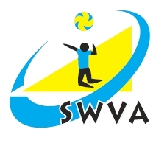
3 Woodside Grove
Henbury, Bristol
BS10 7RF

tel 0797 685 0618
Email RRicha7122@aol.com

September 2nd, 2017

Dear Executive Committee Officer / Area Secretary

I would like to remind you about the next SW Executive meeting which will take place on Saturday October 7th at Priory Community School, Weston super Mare.

Can you please let me know if you are / are not able to attend.

Can you let me have your Officer / Area reports by September 28th. I will get reports out in time for the meeting – hopefully on October 2nd / 3rd.

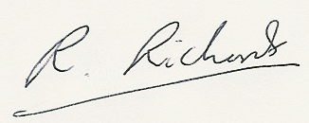
Ron Richards, Secretary, SWVA

